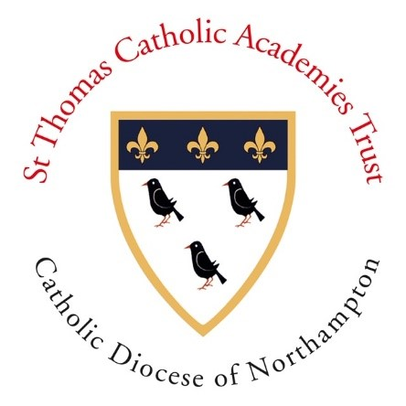
‘Called to Lead’
Click here for introduction to the course from Joe Richardson, the Executive Leader of the St Thomas Catholic Academies Trust.

An invitation to explore leadership opportunities in Catholic schools
Are you a teacher who works in education, but may not currently work in a Catholic school?

Are you interested in school leadership, but not sure whether you could be a leader in a Catholic school?

If you are a Catholic and interested in school leadership,
the ‘Called to Lead’ invitation is for you!

Why we are offering this short course:
The future of Catholic Education relies on strong leadership from leaders committed to their faith and able to share this with the communities they serve.
Over the years we have seen some of the very best Headteachers and school leaders come from settings outside our Catholic schools or emerge in people where career paths did not include leadership in our Catholic schools. Despite this, for colleagues outside of the Catholic Schools sector we understand it can be daunting to consider a position within a Catholic school where your only experience of Catholic education may have been as a child.
We aim to help participants in this course overcome any barriers there may be to taking the first steps towards applying for leadership roles in our schools.
We want to:
- Help you realise the jobs we have in our schools ARE for you
- Help you to appreciate that it is the integrity of your faith and love of God that determines your readiness for leadership and that experience within a Catholic school - while desirable – is not essential
- Help you understand how Catholic schools work through expert teams to provide an environment where faith formation is given space to breathe
- Help you understand how leaders in Catholic schools think and weave Catholicity through all they do
- Give you a forum to ask any questions
- Help you understand the interview and application process
Called to Lead is: | Called to Lead is not:
- an invitation to get guidance and support from some of the very best leaders in Catholic education  - a four-session course for people who would like to explore whether Catholic leadership in our Catholic schools is for them  - based on discussion  - an opportunity to be paired with a serving Headteacher who will act as a mentor, guiding you through any application and interview process | - a course with assignments and accreditation  - an assessment of your suitability to lead – it is an invitation!

The course leaders:
Session 1 - Ani Magill:  Why this job IS for you and nobody else!  Date: 24th February  Time: 7pm | Ani is the Executive Leader of the Xavier Catholic Education Trust which is home to some of the most successful schools in the country. Ani has a remarkable track record, inspiring dozens of teachers to become highly effective Headteachers of the years. She will no doubt inspire you too. The mission statement for the XCET is ‘Striving for excellence’. You will get a sense of that when you meet Ani.
Session 2 - Martin Bonner: Leading Spirituality and prayer in a Catholic school when you may not have a degree in theology – the power of the team | Martin is the Headteacher of St Thomas More School, Bedford. St Thomas More has a rich tradition of excellent provision and the success of the school can in no small part be traced through to the investment in the Spiritual wellbeing of the community. Martin is the latest Headteacher to have the privilege of working with a great team and he will offer his reflections on how you lead a Spiritual community.
Session 3 - Fiona Maynard: Weaving our faith through all aspects of school life – making each school distinctly Catholic | Fiona is Headteacher of St Ethelbert’s Catholic Primary School, Slough. Over the years of her work with the school St Ethelbert’s has gone from a school in need of significant improvement to what it is today – an Outstanding Catholic school. Fiona will share her experiences of school improvement and how you achieve that through the distinctive characteristics of a Catholic school.
Session 4 - Fr Brendan Seery: Working with clergy and any questions you ever wanted to ask a priest! | Fr Brendan is the odd one out! He is not a Headteacher or school leader in the way that Ani, Martin and Fiona are, but he is absolutely part of school leadership through the work of the St Barnabas Cluster in Milton Keynes, supporting the local schools in partnership with the rest of the St Barnabas Cluster. Fr Brendan is very much part of the fabric of our Diocesan schools too, spending his primary school years at St Martin de Porres School, Luton. He will offer insights in the ways in which clergy will be there to support you in your work.

Registration:
It you would like to be supported to move into leadership positions in our Catholic Schools, please complete the form attached here. The date and time of sessions 2 – 4 will be confirmed in due course.

